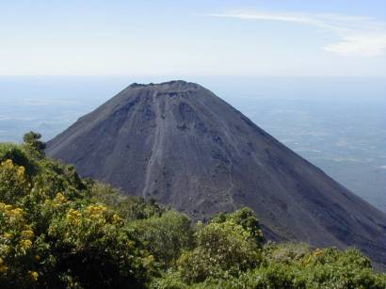
Volcano Tacaná. Border between Guatemala and Mexico

DELIVERY OF FOOD TO POOR FAMILIES

January 9th

ASSUMPTION PARISH
Created by: P. Silverio

Delivery of food to poor families.

From the 22nd to the 23rd of December, 2020
At an early hour on the 22nd we unloaded the truck that transported the food from the the stores of Finca Labor de Castilla in Zone 9 of Mixco, Guatemala to Tacaná.
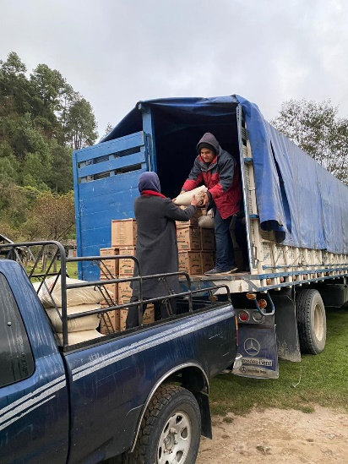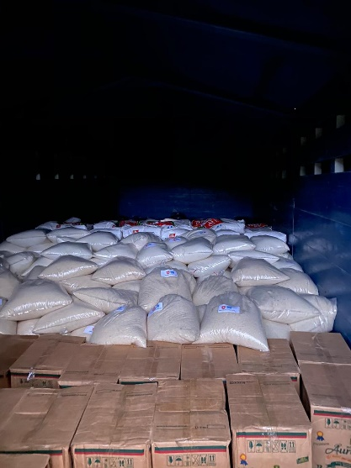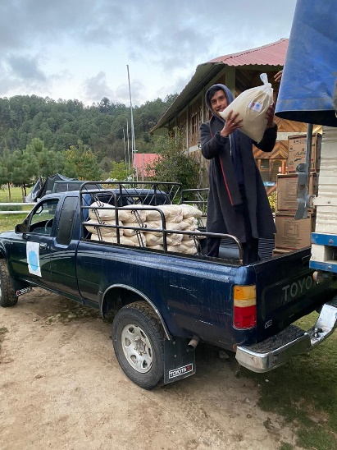
Loading the first Trip Truck with the groceries First rations to be delivered

Afterwards we loaded the pickups to distribute the food to 230 families in 17 communities of our parish. It was two days of arduous work, but with the satisfaction of having partially reduced the need of the families.

Various Communities Benefited
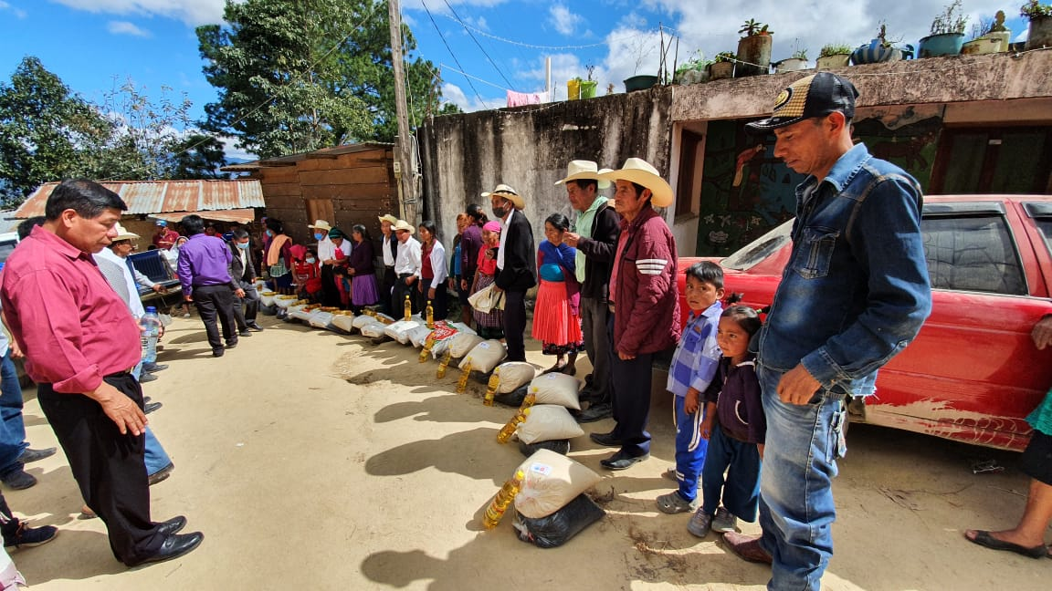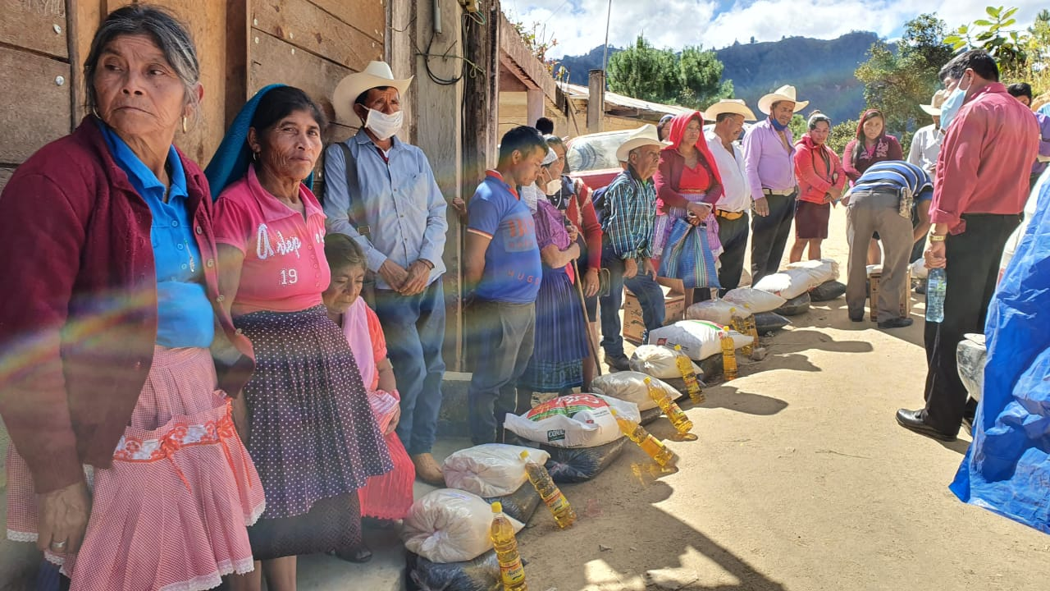
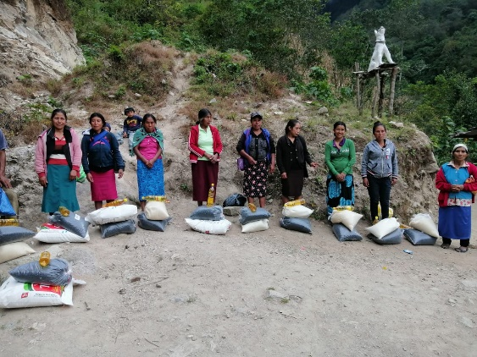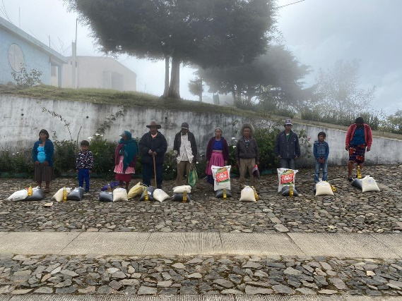
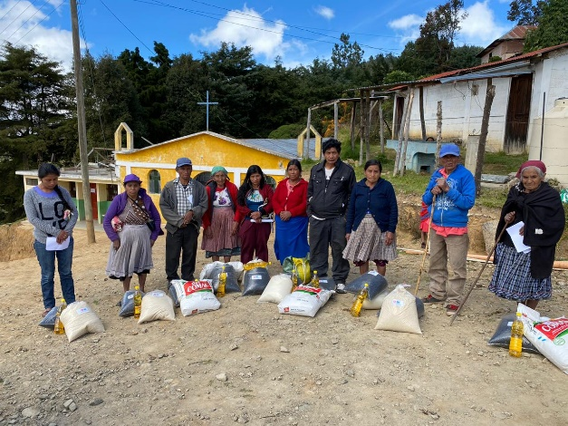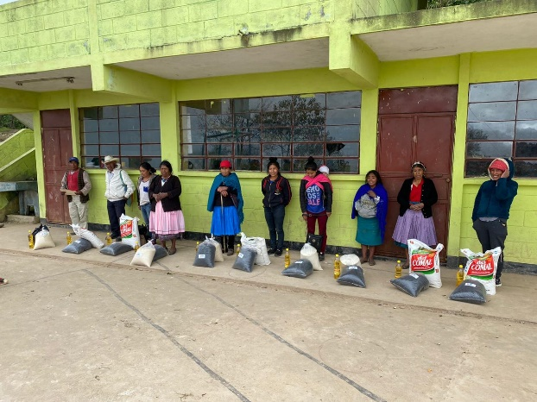

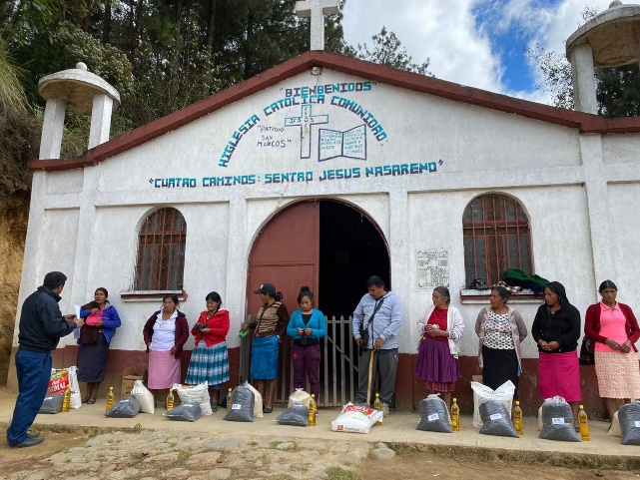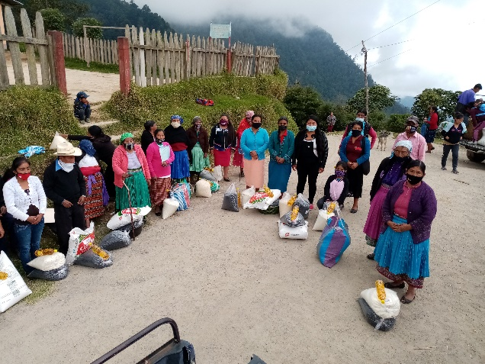

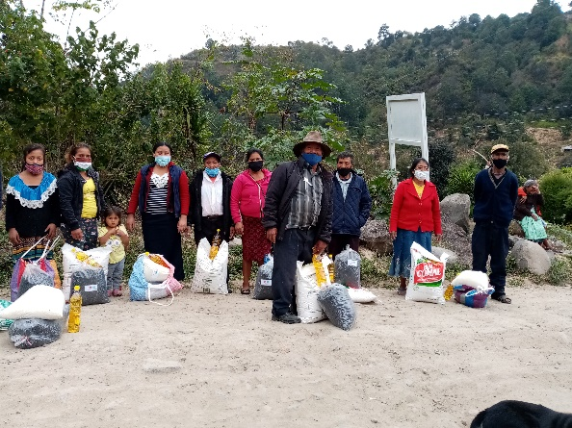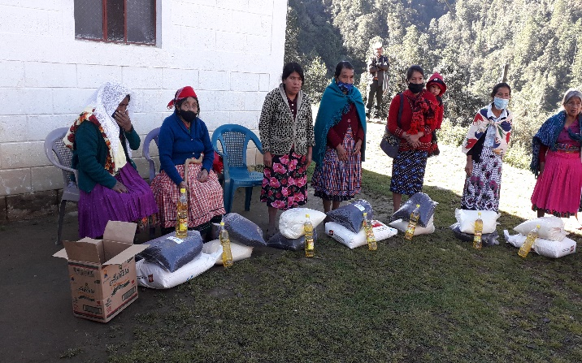

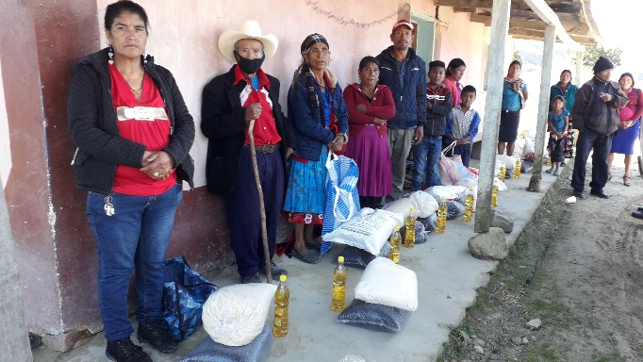

Leaving for their homes after having received their rations.

Some with the help of their children.
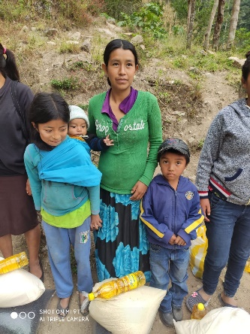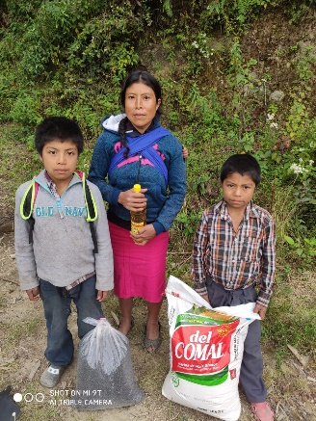
Others by themselves.
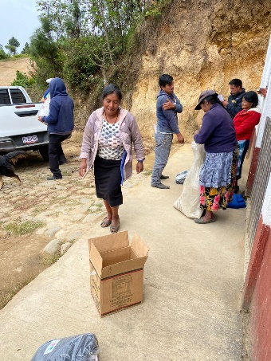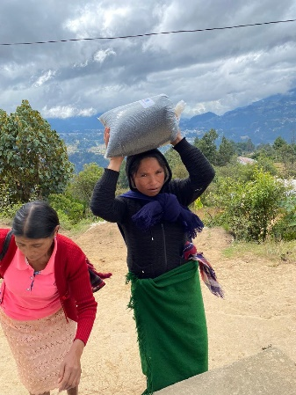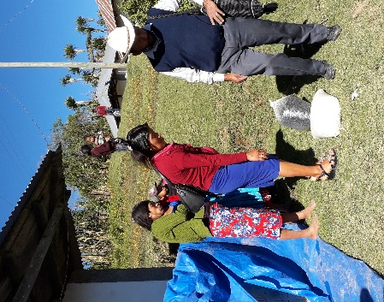

We tell the story of poverty lived by Doña Clara Morales Bravo de Rodriguez from Caserio Cuatro Caminos, who has 4 small children.
Having arrived at her humble home Her small daughter awaits her
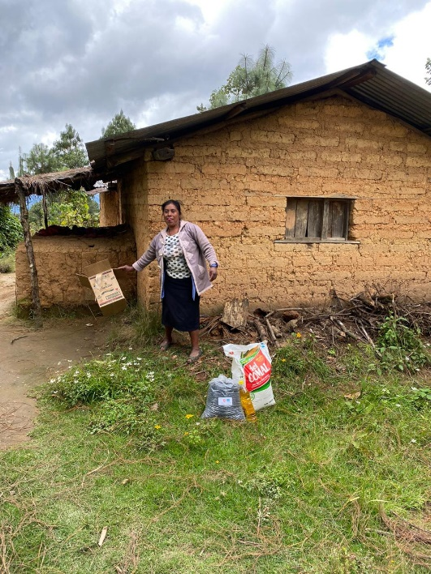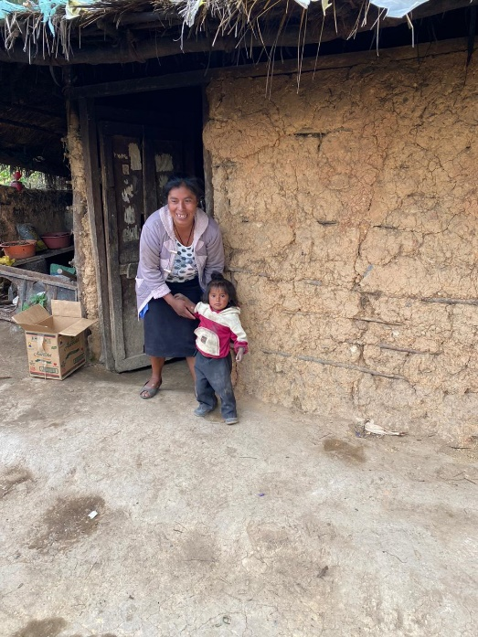

She goes running to her other siblings. Steam bath.
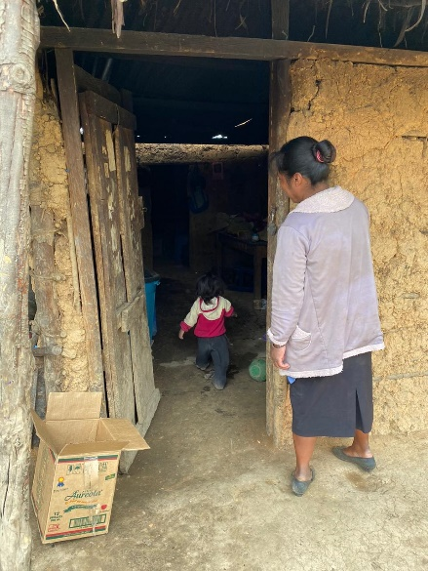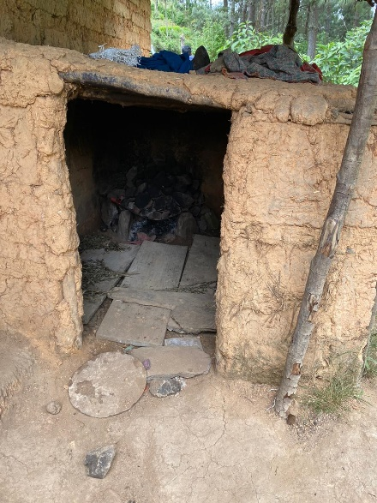

Doña Clara Morales expresses her sad economic reality, as she lives day from to day, washing clothes in the homes of those who give her work. If it goes well for her she brings home food, and if not she comes home with sadness because she has no food to share with her 4 small children. Such is the scarcity of food that one of her children suffers from malnutrition. And her husband, who is a farmer, barely helps her with food since having no education he dedicates himself to growing corn.

This case, like the many others that exist in Tacaná, is so sad to relate, and a photo tells more than a thousand words.

Some houses of the beneficiaries, who have scarce resources. In the second photo Padre Silverio appears.
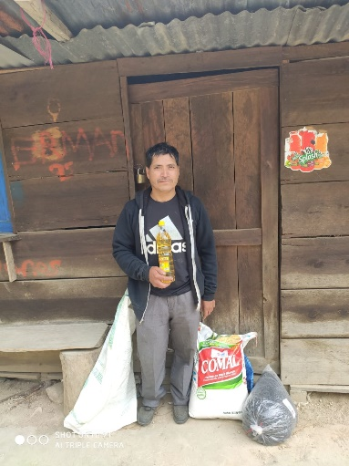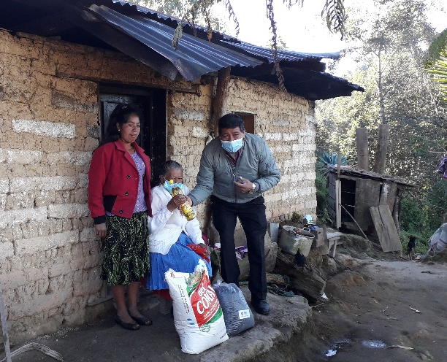
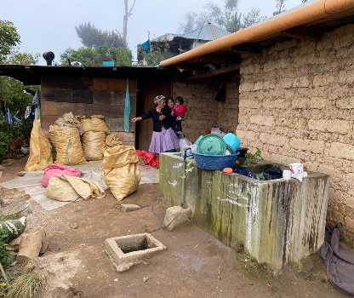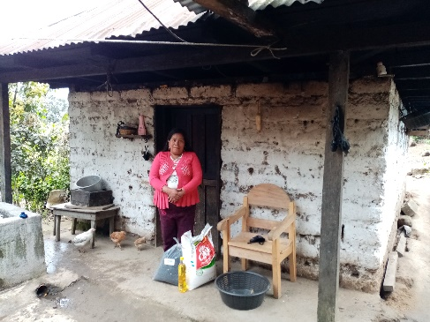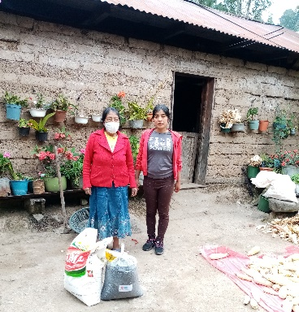

Also, from the parish a bag of candy is given to the children who are with their parents.
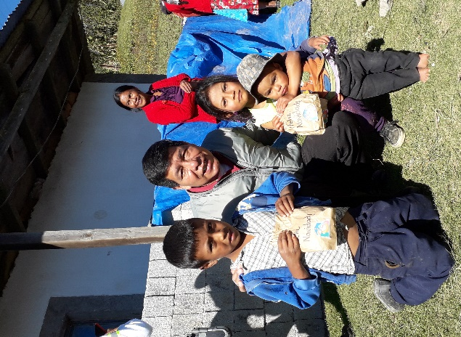
Many people in Guatemala are poor. Tacaná is not an exception. Her population also has families in extreme poverty, as seen in the photos..
The majority of the beneficiaries are elderly, homemakers, and persons with disabilities. These are the ones who need help.
