Corona Bingo Challenge
Hi everyone! Each week, by Sunday morning, I will send a packet for the upcoming week. The packet will have a Bingo card that the kids (and other family members) can partake in to win! I will rely on you parents to provide a fun treat for the winner!
Content:
In the Bingo card, there will be a variety of activities included. Some are to be done as a family, some individually. Some will be done online, some without the computer. Some will be live, others recorded. There will be a blend of content, prayer, and fun activities. This week, there will be nine activities in which everyone can take part.
Scoring:
Players receive 1 point for every bingo (three in a row) and 10 points for a blackout.
At the end of the week, take a photo of the winner holding his/her Bingo card and send it to me via Remind. With how many points he/she got. Even if only one person plays, please send a photo at the end of the week so we can recognize the winners!
There will be explanations of activities in the following pages.
If you have questions, the easiest way to reach me is through Remind. If you are NOT registered on Remind, the class codes are as follows:
- Wednesday English Speaking EDGE Families: @6a8bf7
- Wednesday Spanish Speaking EDGE Families: @dhbahh
- Sunday English Speaking EDGE Families: @7gfk3a
- Sunday Spanish Speaking EDGE Families: @bdcda6
- Home Study Families: @3f4f7b
This will be our trial run week. Please encourage your kids to participate. We aim to continue to have live, interactive events Sundays at 4pm and Wednesdays at 6:30pm at least over the next few weeks.

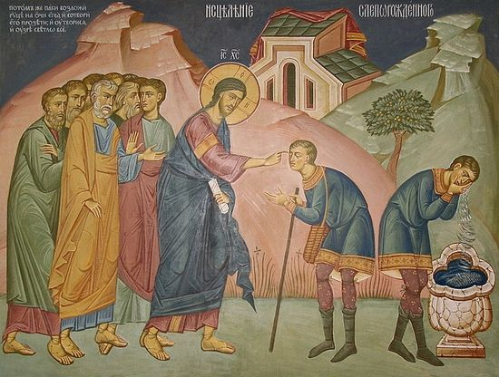
Fourth Sunday of Lent Family Gospel Reflection
1
This can be done interactively at 4pm on Sunday, 3/22 via Zoom, or simply together as a family at home.
Leader: Begin with prayer - asking the Lord for protection over you and the whole world. Then pray 1 Our Father, 1 Hail Mary, and 1 Glory Be. You should have a leader and a reader for this activity.
Leader: Today’s Gospel speaks about a blind man that Jesus healed. Jesus does something that seems very strange in order to heal him. He mixes spit and dirt, rubs it on the man’s eyes, and tells him to go take a bath. Let’s see what happens when he does.
Reader: As Jesus passed by, he saw a man blind from birth. He spat on the ground and made clay with the saliva, and smeared the clay on his eyes, and said to him, “Go wash in the Pool of Siloam” — which means Sent — So he went and washed, and came back able to see.
Leader: What happened to the man after he bathed in the pool? How do you think he felt? Do you think the people in the town were happy for him?
Leader: Now let’s read what happens next:
Reader: His neighbors and those who had seen him earlier as a beggar said, “Isn’t this the one who used to sit and beg?” Some said, “It is, “but others said, “No, he just looks like him.” He said, “I am.”
They brought the one who was once blind to the Pharisees. Now Jesus had made clay and opened his eyes on a sabbath. So, then the Pharisees also asked him how he was able to see. He said to them, “He put clay on my eyes, and I washed, and now I can see.” So, some of the Pharisees said, “This man is not from God, because he does not keep the sabbath.” But others said, “How can a sinful man do such signs?” And there was a division among them. So, they said to the blind man again, “What do you have to say about him, since he opened your eyes?” He said, “He is a prophet.”
Leader: What was the reaction from those around the man? What is a Pharisee?
The Pharisees had a rule that you could not work on the Sabbath. What did they think Jesus had done wrong?
Reader: They answered and said to him, “You were born totally in sin, and are you trying to teach us?” Then they threw him out. When Jesus heard that they had thrown him out, he found him and said, “Do you believe in the Son of Man?” He answered and said, “Who is he, sir, that I may believe in him?” Jesus said to him, “You have seen him, and the one speaking with you is he.” He said, “I do believe, Lord,” and he worshiped him.
Leader: What did the man say about Jesus? What did he do after saying that? What does it mean to worship God? What is the absolute most perfect way to worship God each week?
Let’s watch this video that gives a visual for this story: https://www.youtube.com/watch?v=X4qZ2KSbdxI
Discuss any things you noticed in the video that helped clarify the passage. From there, end in prayer!
Fourth Sunday of Lent Family Gospel Activities
2
Choose One of the Following to Complete Square Two
Color It!
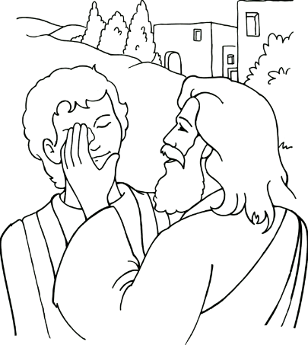
https://sermons4kids.com/healing_blind_colorpg.htm. You can either make this larger or click on the link, print, color.
On the back, write a prayer thanking Jesus for helping you stay healthy.
Act It Out!
Can you family act out the story of the man born blind? Record it, watch it together and imagine how grateful that man must have been to Jesus. What are YOU thankful for this week?
List It!
Can your family come up with a list of what you are grateful for? Have each person pick one that they have been especially grateful for this past week.
Discuss It!
As a family, are you strong in worshipping Jesus? Do you attend Mass each week? Pray before meals? Worship him through obedience to parents, government officials, coaches, priests, etc.? Do you make time for personal prayer? Take some time to decide how you can grow in this area so if someone asked you about Jesus, you could say, “I do believe!” and you show this belief through worship.
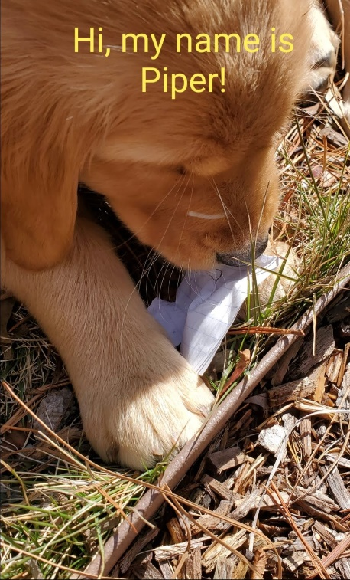
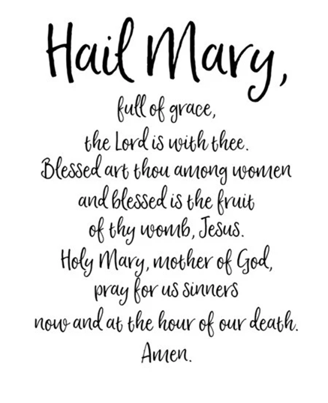
Hail Mary Walks!
3

You Should Learn Your Prayers in the Order Below: In order to put an X on your bingo card, you have to learn a NEW prayer or a prayer in a different language!
4
Sign of the Cross  In the name of the Father,  And of the Son,  And of the Holy Spirit.  Amen. | Our Father  Our Father, who art in heaven,  hallowed be thy name;  thy kingdom come;  thy will be done  on earth as it is in heaven.  Give us this day our daily bread;  and forgive us our trespasses,  as we forgive those who trespass against us;  and lead us not into temptation,  but deliver us from evil.  Amen. | The Hail Mary  Hail, Mary, full of grace.  The Lord is with thee.  Blessed art thou among women,  and blessed is the fruit of thy womb, Jesus.  Holy Mary, Mother of God,  pray for us sinners,  now and at the hour of our death.  Amen.
Glory Be

Glory be to the Father,
and to the Son,
and to the Holy Spirit.
As it was in the beginning,
is now, and ever shall be,
world without end.
Amen.
La Señal de la Santa Cruz  En el nombre del Padre  y del Hijo  y del Espíritu Santo  Amen | Padre Nuestro  Padre nuestro, que estás en el cielo, santificado sea tu Nombre; venga a nosotros tu reino; hágase tu voluntad  en la tierra como en el cielo.  Danos hoy nuestro pan de cada día; perdona nuestras ofensas, como también nosotros perdonamos a los que nos ofenden; no nos dejes caer en la tentación, y líbranos del mal. Amén | Ave Maria  Dios te salve María  llena eres de gracia  el Señor es contigo;  bendita tú eres  entre todas las mujeres,  y bendito es el fruto  de tu vientre, Jesús.  Santa María, Madre de Dios,  ruega por nosotros, pecadores,  ahora y en la ahora  de nuestra muerte. Amén
Gloria

Gloria al Padre, y al Hijo, y al Espíritu
Santo. Como era en el principio, ahora
y siempre, por los siglos de los siglos.
Amén

5
Sunday Mass
Go to https://livestream.com/accounts/29266038/events/9051151 to participate Mass at 10:00 (English or 12:00 (Spanish). Participate in the Mass - don’t just watch.

6
Diving into Scriptures!
Use post-its/index card and write down a bible verse that you think is relevant based on how your day went and write down why you chose that verse. After, take the time of the day to reflect on it.
You should have 7 post-its/index cards by the end of the week. (1 for each day)
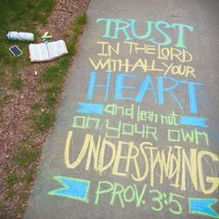 Make sure you pick your own verse!
7
8

9
Come together for a fun night of EDGE!

a high-ranking Jewish official who thought that following all the rules strictly was what made you holy. They were often self-righteous and wanted to trick Jesus into breaking the rules
Cured on the sabbath
There is no question on this, but for a little background: The Jewish people thought that blindness was the result of sins of past generations. When the Pharisees say that he was “born into sin” they are speaking of his blindness.
Participate in the Mass

