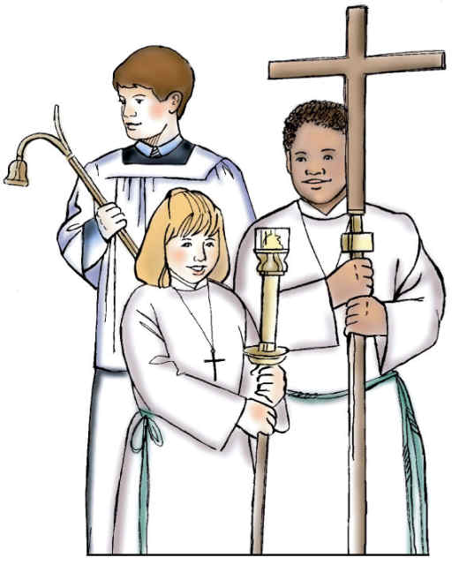
St Paul Catholic Church
Altar Server Manual

Index

Tab 1 – Things to Know and Master

Tab 2 – Order of Mass and Duties of the Altar Servers

Tab 3 - Daily Mass Duties of the Altar Servers

Tab 4 - Sacred Vessels, Linens and Books

Tab 5 – Altar Servers Modified Procedures for
Masses at St Paul Catholic Church
- During COVID-19 Pandemic

