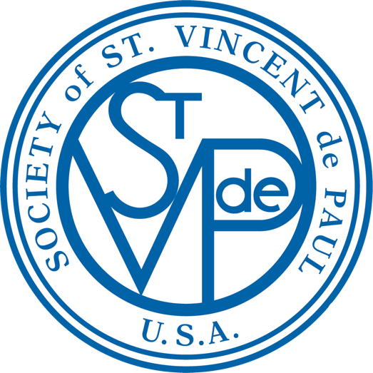
_{September 2021} News from St. Vincent de Paul
St. Mary Conference

Lord, we ask for the grace to have a Vincentian heart. We give you our gifts and talents, our dreams and visions so that we may carry the mission of St. Vincent. We ask for the grace to bring mercy to the broken hearts of the poor. Amen

FISHES AND LOAVES – YOU MAKE A DIFFERENCE
The story about Jesus’s multiplication of the loaves and fishes in the gospel of Luke seems like a very simple story on the surface of things. Jesus recognized that all good gifts come from our Heavenly Father and gave 5,000 people bread and fish to eat from 5 barley loaves and 2 fish. We at St. Vincent de Paul wondered how our gifts could be put to good use for our parish family or the larger community that we live in.
Because of all of you and your generosity, we were able to reach out to help others by contributing to the Cathedral Soup Kitchen, Laurita Vicuna Orphanage, St. Andrew Parish, Holy Angels Parish, St. Gabriel Parish and St. Anthony Parish who lack the resources to serve their communities. We also provided cooking appliances to the Distribution Center and assisted a family from our parish with utility payments.
Let us try to be good to each other while we journey through life together, and share what we have with one another, just like the little boy in gospel of Luke, who shared his bread and his fish with everyone. His small gift of fish and bread ended up making a big difference to five thousand people that day, and his memory lives on throughout the ages because of how Jesus used his small gift. Thank you for your gifts which will make a difference to many.

Thanks to all parishioners who donate to the 5th Sunday collection .Because of you, we were able to help 9 families with utility assistance amounting to $1,952.71 in 2021.___

ST. VINCENT DE PAUL ANNUAL MEETING
St. Vincent de Paul will be hosting its Annual Council Meeting on Sunday, September 26, from 8:30am-1:30pm at the SVdP Food Pantry 3001 E. 30th Street. We are excited to get together and review the highlights from the past year, participate in Mass, experience fellowship and recognize amazing volunteers. The meeting will include a light breakfast, Mass, membership meeting, volunteer awards and catered lunch. This annual meeting is a great way to learn more about the Society of St. Vincent de Paul and fellowship with SVdP leadership, Vincentians, and volunteers. This year’s meeting will be hosted by the East District Conferences of which St. Mary’s is a part. The meeting date is one chosen closest to the feast day of St. Vincent de Paul (9/27) who was a French Catholic priest who is known for his apostolic work among the poor and marginalized. COVID masks are optional for those fully vaccinated but are mandatory for all others. Questions: Jeni Christoffersen jeni@thechristoffersens.com 317-417-5378.
RSVP today: http://www.svdpindy.org/event/annual-meeting-2/.

VOLUNTEERS NEEDED
The need in our community for food and household goods is tremendous. Can you devote a little time to help those in need? Volunteers are needed at our Food Pantry 3001 E. 30th Street and our Distribution Center 1201 E. Maryland Street. Come with your family, your friends, your coworkers … have fun while serving others. Contact information is listed in the right-hand column … come join our volunteer team – we would welcome the opportunity to have you with us.

“Let me be as Christ to you. Pray that I may have the grace to let you be my servant too.”

THINGS YOU SHOULD KNOW

Have items to donate? For furniture/large items call for pickup: 317-687-1006.
For clothing/soft goods find drop box locations http://www.svdpindy.org/i-want-to-help/find-a-clothing-bin/
Drop off at the loading dock at 1201 E. Maryland Street. Monday-Saturday 10am-4pm

Know someone in need of household items? Have them call our Help Line 317-687-0169 or complete a form online http://www.svdpindy.org/i-need-help/household-basics-help-request-form/

Want to Volunteer? Sign up today: http://www.svdpindy.org/i-want-to-help/#time. Or Contact Darlene Sweeney dsweeney@svdpindy.org

Want to be part of SVdP at St. Mary? Contact Martha O’Connor moconnor11961@icloud.com

Sign Up for the St. Mary SVdP e-Newsletter and parish news
mriley@stmarysindy.org

Sign Up for the SVdP Council e-Newsletter www.svdpindy.org/subscribe

IMPORTANT DATES
9/13 & 10/11 @ 6pm SVdP Conference Meeting – Rectory
9/26 @ 8:30am-1:30pm SVdP Annual Meeting – SVdP Food Pantry
10/2-3 – Mission 27 participating in Woodruff Place Flea Market
10/31 – 5th Sunday Collection

Follow us on Facebook, Twitter, or www.svdpindy.org
NEWS FROM ST. VINCENT de PAUL INDIANAPOLIS | SEPTEMBER 2021

